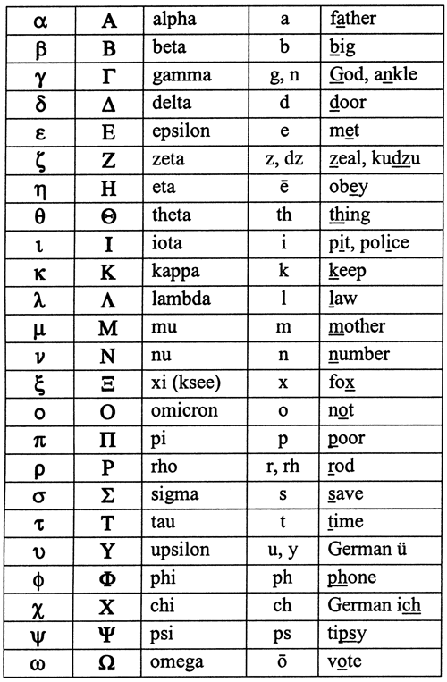 **THE GREEK ALPHABET**